|  |  |  |  |
| --- | --- | --- | --- |
| To: | Pichoff | Subject: | Sales Miner Project |
| From: | Goss | Type: | **Update** RFI Alert |
| Date: | 5 FEB 20 | Concerned Parties: | Annorum Supra, Pichoff, Watkins |
| Client: | Allpax |

Highlights:

-[began reproducing the Sales Opportunity project from last summer](https://github.com/gossdouglas/Annorum-Supra31JAN20/tree/master/Allpax%20Sale%20Miner/Resources).

-database was created on my GoDaddy webserver through SQL Server Management Studio

-[created task guides for my fellow team members](https://github.com/gossdouglas/Annorum-Supra31JAN20/tree/master/Allpax%20Sale%20Miner/Resources)

-[began a project workbook that outlines tasks to be completed and links to aid in their accomplishment](https://docs.google.com/spreadsheets/d/1ueAu4MvaSItuEUik5mhjNKTKFEpN2hUCjPNjK1ol_Sc/edit#gid=0)

-can create, read, update and delete the customer table

-published the project to <http://allpax.gossdouglas.com/>

Next:

-create a controller and view for the customer events table

-

Pichoff,

The status of the project follows.

Software stack:

|  |  |  |  |
| --- | --- | --- | --- |
| MS SQL Server | ASP.net | Jquery for client scripting | Axios for http requests |
| REST | Github for version mgmt | Material Design Bootstrap |  |

Goss

Database-

The SQL database has been begun and lives on my GoDaddy domain at the moment. I realize that a project published to a websiite is a scope bust, but I wanted to use this opportunity to show my group members how to do more advanced things. The table schema is based on concept drawings provided by Watkins last summer.

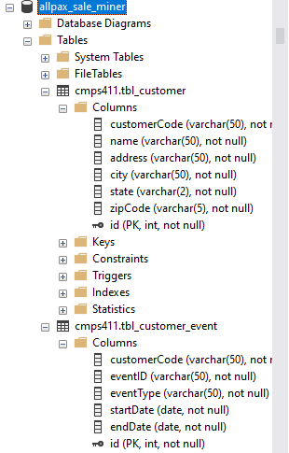

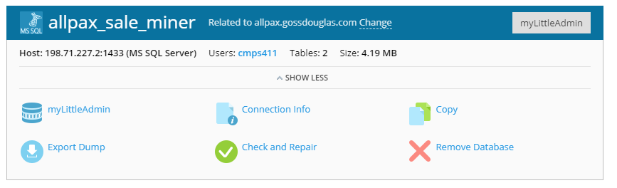

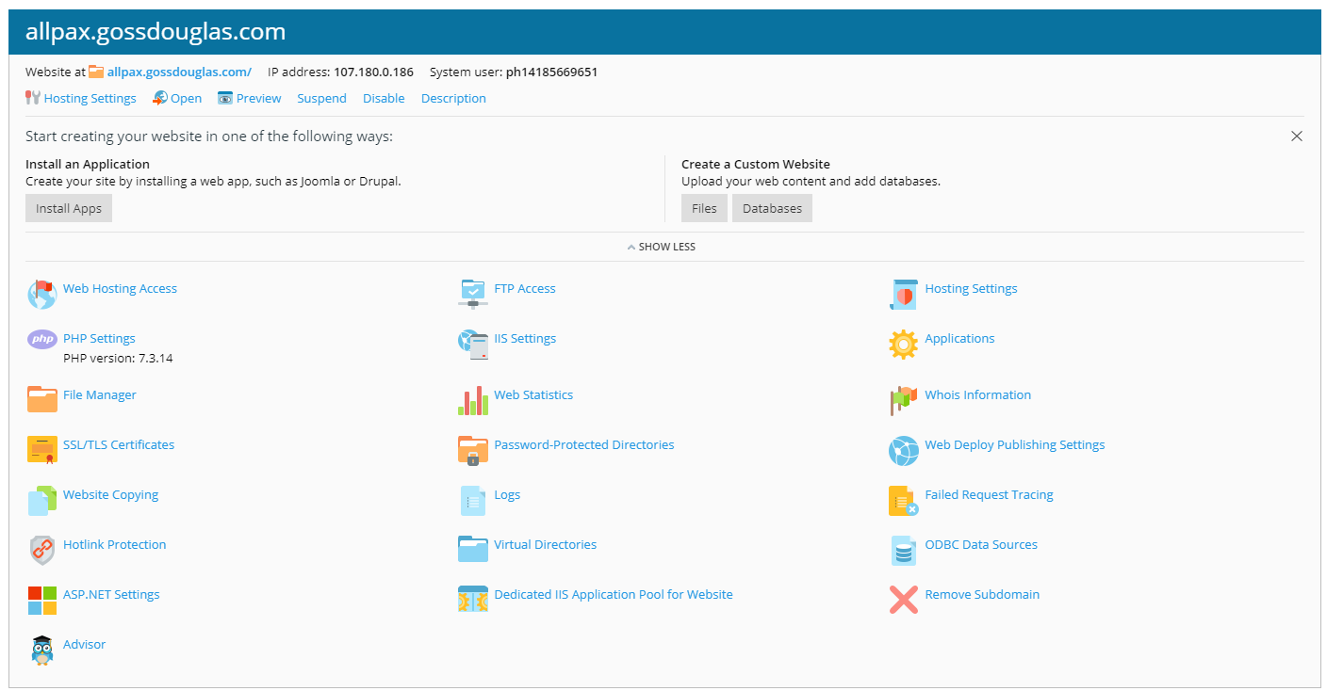

Front End:

The front end has been begun and has been published to allpax.gossdouglas.com. There is no nav link to the only table I’ve published so far, customerMgmt, but it can be reached at the /customermgmt route.

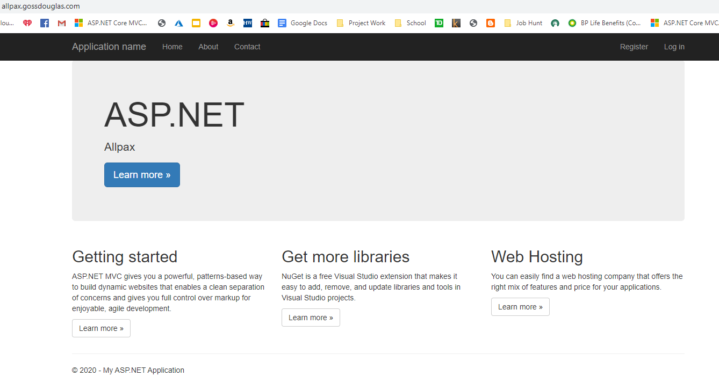

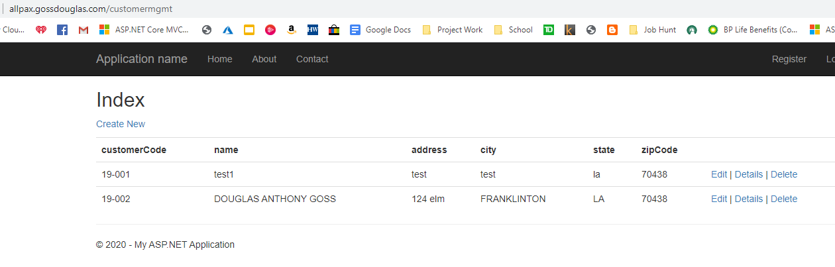

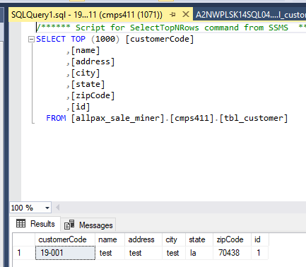

Let’s add a new record.

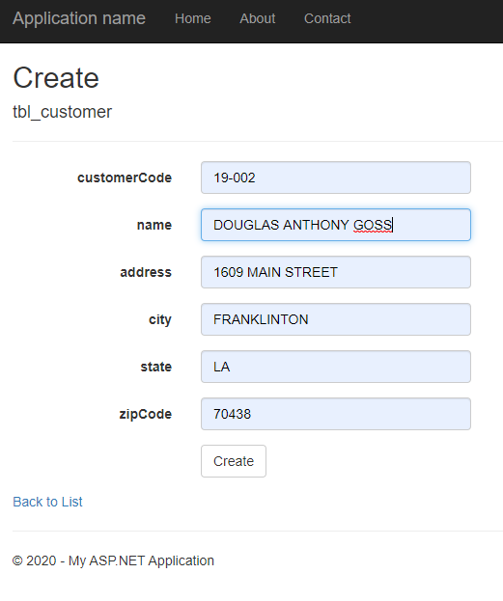 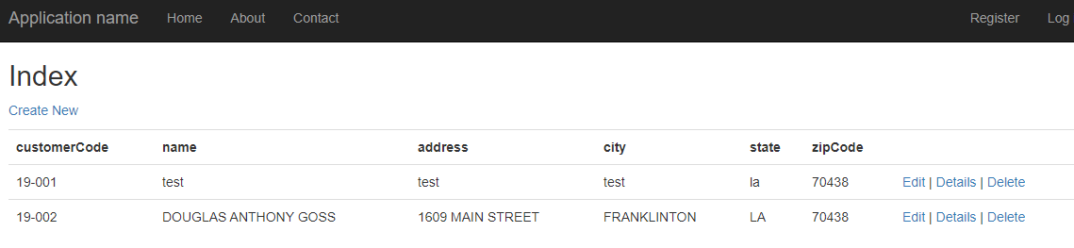

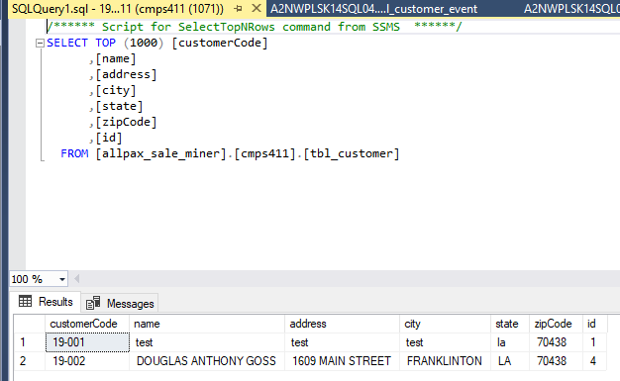



A new record has been added.

It is necessary that we add a unique constraint to tbl_customer. The primary key is the auto-incremented field id.

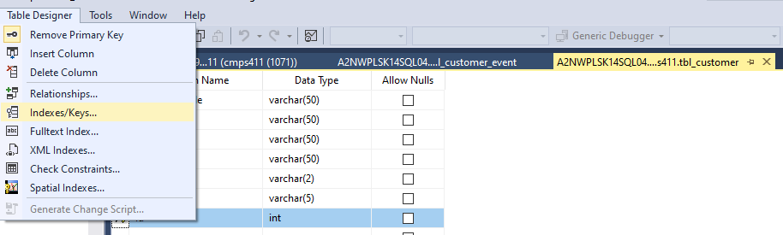

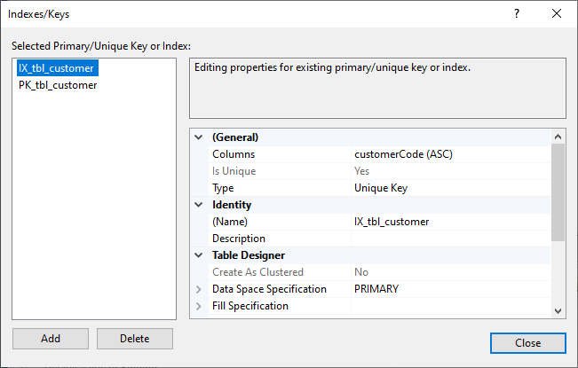

Now, if I add a duplicate of a field that should be unique in the table, I will get an error. We’ll have to figure out how to handle the error in a prettier way later.

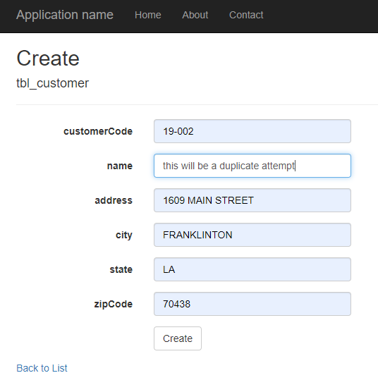

Not today Satan!

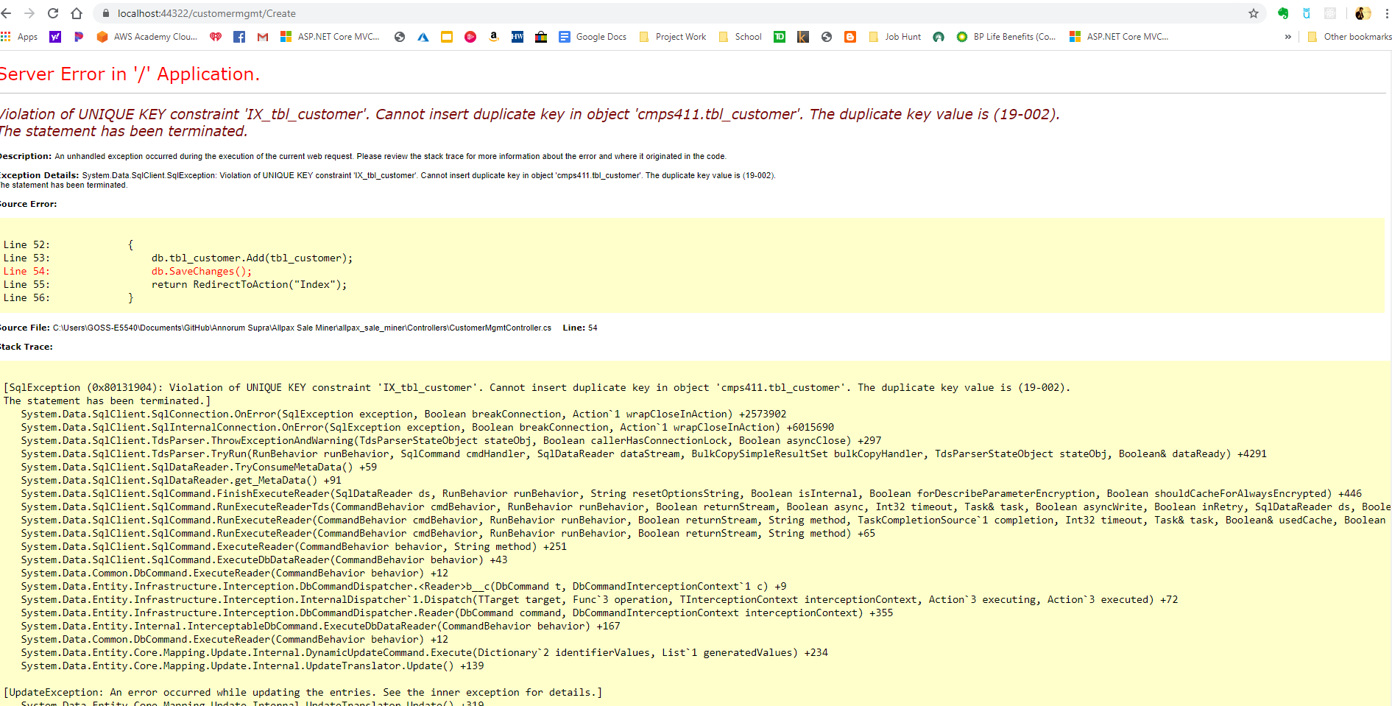

I know Allpax prefers inline editing and while this has not yet been implemented in the new project, I have learned how to do it on another project.

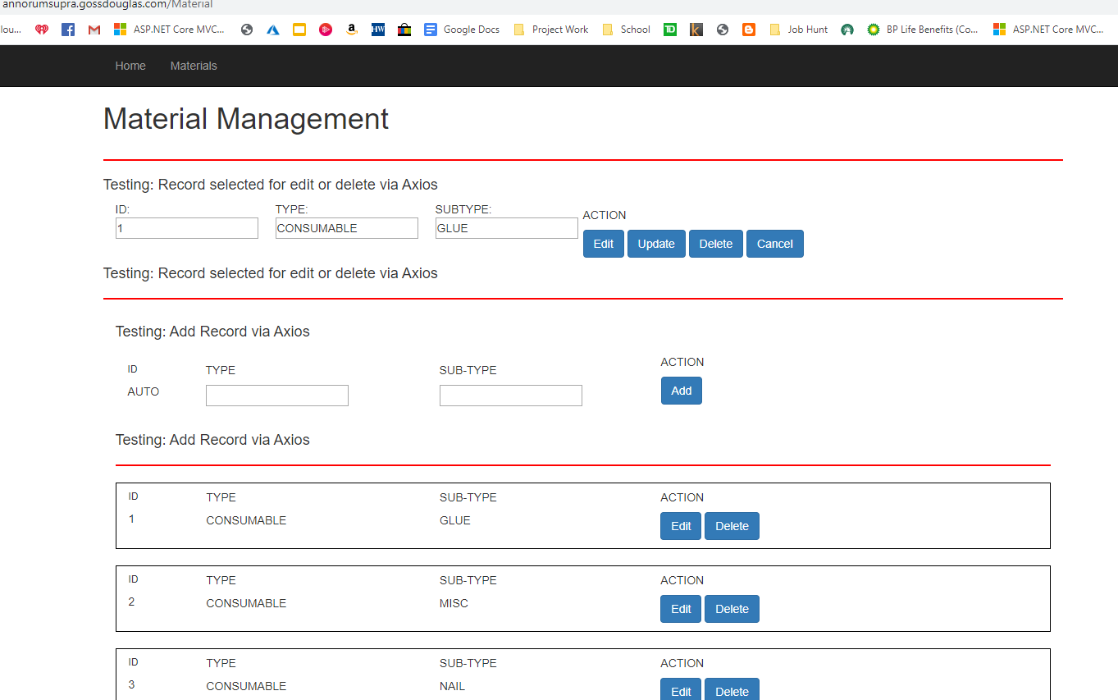

Jquery detects that event. This is the basis for my inline editing.

When a record row is selected…

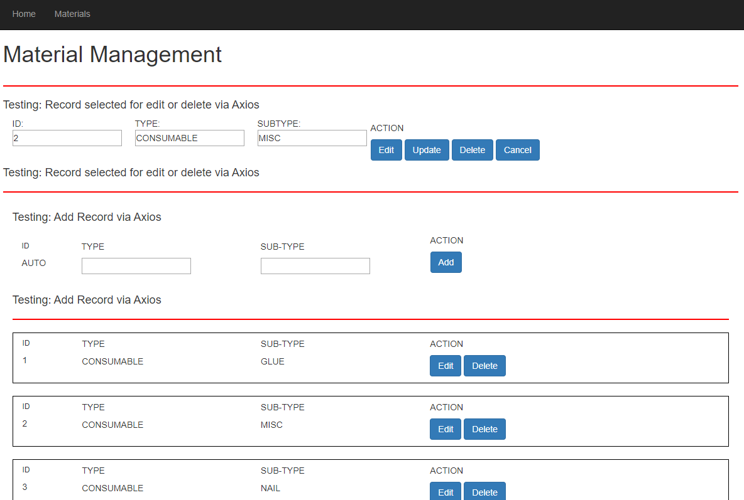

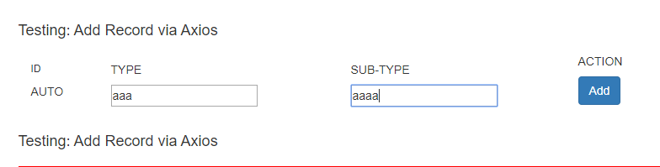

A new record can be added to the database.

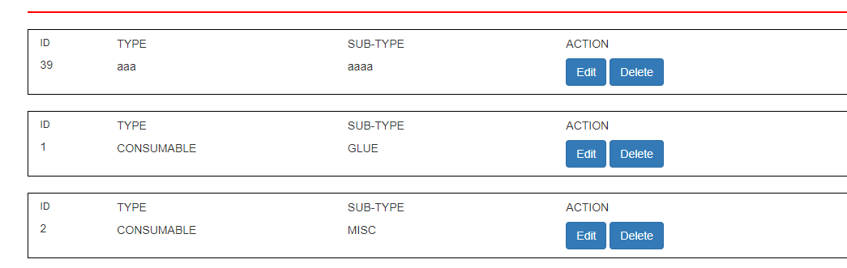

Javascript code has been added to affect the visibility of record buttons.

When the edit button is pressed…



The buttons that are available change.

When the delete button is pressed…



The buttons that are available change.

These features are testable on <http://annorumsupra.gossdouglas.com/Material>